REQUEST FOR QUOTATION FOR THE PRINTING OF MEDICATICATION LABEL/STICKERS (SLEEVES) FOR KNCV TUBERCULOSIS FOUNDATION NIGERIA

REFERENCE NO. – KNCVN-DAT- MLS -P/21/26-01

General Information:
KNCV is inviting vendors to provide quotations for the printing and supply of Medication Labels/stickers.
- Vendors are required to submit quotation indicating cost, payment, and delivery terms of Medication Labels/stickers as specified below:

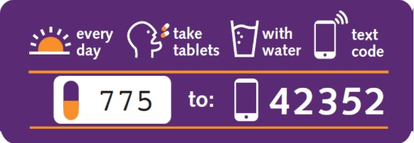
SAMPLE LABEL DESIGN

DIMENSIONS | 10 cm x 1.6 cm
ADHESIVE | The label will be placed on a (plastic) medication blister
COLOR | Full color-yellow moon color retained, all white letters and colors retained and the majority pink to change to green.
DESIGN | A sample label design is shown below
VARIATIONS | All labels have the same design, but 20 different 3-digit codes should be used
DELIVERY | Labels should be delivered on a label roll or label sheet
QUANTITIES MATERIAL | 12,000 labels in total (500 per batch with the same 3- digit codes)  Vinyl stickers to be placed on drug Sachets- the area with the letter “775” in the sample below to come in scratch card form.

Delivery location: Independence Avenue, Central Business District (CBD) FCT, Abuja.

Submission of Quotes:
- Submit quotation on both the attached KNCV RFQ and on your company letterheaded document
- Fill and submit KNCV Vendor information form (form attached)
- All bids must be written in English and signed by an authorized person
- Bids submitted after the closing date/time will not be considered
- A minimum of 5% WHT will be deducted per invoice as required by FIRS
Eligibility Requirements:
To be eligible to participate in this process, vendors must provide proof of all the following documents:
- Company’s registration documents/certificate of incorporation with Corporate Affairs Commission (CAC), Form CO2 & CO7
- A recent Tax Clearance Certificate
Evaluation Criteria
The criteria for evaluation shall include
- Cost
- Payment terms
- Delivery terms
- Production and approval of very high-quality sample (next level evaluation)
Submission:
Open Date/Time: 4:00pm Wednesday July 28, 2021
Close Date/Time: 12noon Monday August 2, 2021

Procedure for Submitting:
Vendors are to submit requested documentation BY E-MAIL (only) – to procurement@kncvnigeria.org
All attachments to be in 1 PDF document with Title:
“Name of your Organization” for THE PRINTING OF MEDICATICATION LABEL/STICKERS – KNCVN-DAT- MLS -P/21/26-01

Selection process
The selected vendor will be contacted via e-mail, immediately after the selection process is concluded.

N/B
- KNCV shall only accept from the selected vendor – “company banking details” not individual/private banking details
- KNCV shall not pay VAT (exemption certificate may be provided to selected vendor on request)

